Module 2:

INSTRUCTION SET OF INTEL 8085:

**I.Instruction Format**

 An instruction is a command to the microprocessor to perform a given task on a specified data.

* Each instruction has two parts: one is task to be performed, called the operation code (opcode), and the second is the data to be operated on, called the operand. The operand (or data) can be specified in various ways. It may include 8-bit (or 16-bit) data, an internal register, a memory location, or 8-bit (or 16-bit) address. In some instructions, the operand is implicit.

**Instruction word size**

The 8085 instruction set is classified into the following three groups according to word size:

ü One-word or 1-byte instructions

ü Two-word or 2-byte instructions

ü Three-word or 3-byte instructions

In the 8085, "byte" and "word" are synonymous because it is an 8-bit microprocessor. However, instructions are commonly referred to in terms of bytes rather than words.

**1 One-Byte Instructions**

A 1-byte instruction includes the opcode and operand in the same byte. Operand(s) are internal register and are coded into the instruction

[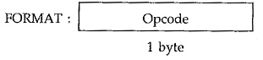](http://www.eeeguide.com/wp-content/uploads/2018/07/Instruction-and-Data-Format-of-8085.jpg)

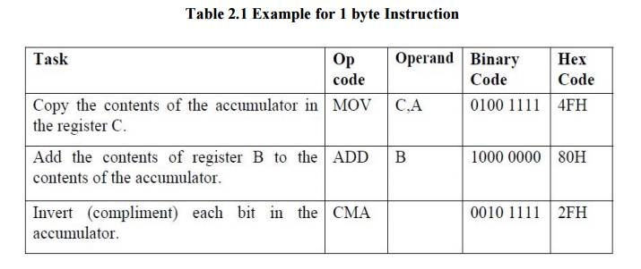

These instructions are 1-byte instructions performing three different tasks. In the first instruction, both operand registers are specified. In the second instruction, the operand B is specified and the accumulator is assumed. Similarly, in the third instruction, the accumulator is assumed to be the implicit operand. These instructions are stored in 8- bit binary format in memory; each requires one memory location.

**2 Two-Byte Instructions**

In a two-byte instruction, the first byte specifies the operation code and the second byte specifies the operand. Source operand is a data byte immediately following the opcode. For example:

[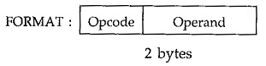](http://www.eeeguide.com/wp-content/uploads/2018/07/Instruction-and-Data-Format-of-8085-1.jpg)

**Table 2.2 Example for 2 byte Instruction**

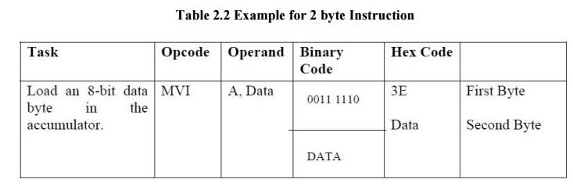

The instruction would require two memory locations to store in memory.

**3 Three-Byte Instructions**

 In a three-byte instruction, the first byte specifies the opcode, and the following two bytes specify the 16-bit address. Note that the second byte is the low-order address and the third byte is the high-order address.  opcode + data byte + data byte

[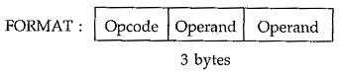](http://www.eeeguide.com/wp-content/uploads/2018/07/Instruction-and-Data-Format-of-8085-2.jpg)

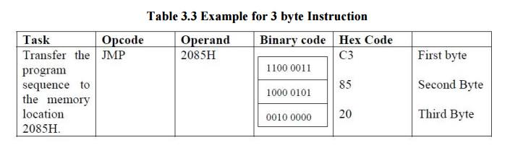

This instruction would require three memory locations to store in memory.

 Three byte instructions - opcode + data byte + data byte

**II. Addressing modes**

To perform any operation, we have to give the corresponding instructions to the microprocessor. In each instruction, programmer has to specify 3 things

: 1. Operation to be performed.

2. Address of source of data.

3. Address of destination of result

* The method by which the address of source of data or the address of destination of result is given in the instruction is called Addressing Modes.
* The term addressing mode refers to the way inϖ which the operand of the instruction is specified.

**Intel 8085 uses the following addressing modes:**

1.Direct Addressing Mode

2.Register Addressing Mode

3.Register Indirect Addressing Mode

4.Immediate Addressing Mode

5.Implicit Addressing Mode

1. . Direct Addressing Mode

In this mode, the address of the operand is given in the instruction itself.

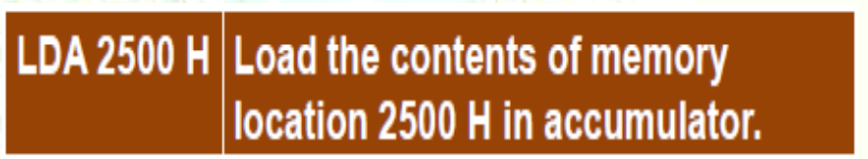

* LDA is the operation.
* 2500 H is the address of source.
* Accumulator is the destination.

2. Register Addressing Mode

In this mode, the operand is in general purpose register.

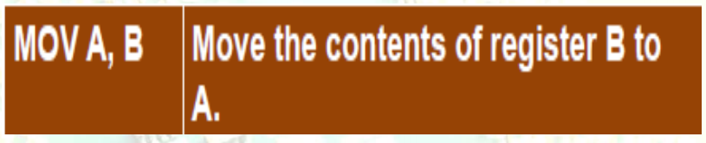

* MOV is the operation.
* B is the source of data.
* A is the destination.

3. Register Indirect Addressing Mode

In this mode, the address of operand is specified by a register pair.

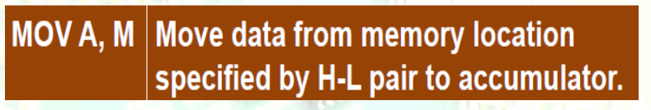

* MOV is the operation.
* M is the memory location specified by H-L register pair
* . A is the destination.

4. . Immediate Addressing Mode

In this mode, the operand is specified within the instruction itself



* MVI is the operation.
* 05 H is the immediate data (source).
* A is the destination.

5. Implicit Addressing Mode

If address of source of data as well as address of destination of result is fixed, then there is no need to give any operand along with the instruction.

* CMA is the operation.
* A is the source.
* A is the destination

**III Status flags**

**Flag register in 8085 microprocessor**

The Flag register is a Special Purpose Register. Depending upon the value of result after any arithmetic and logical operation the flag bits become set (1) or reset (0). In 8085 microprocessor, flag register consists of 8 bits and only 5 of them are useful.

The 5 flags are:

D0

D1

D2

D3

D4

D5

D6

D7

|  |  |  |  |  |  |  |  |
| --- | --- | --- | --- | --- | --- | --- | --- |
| S | Z | x | AC | x | P | x | CY |

The positions marked by “x” are to be considered as don't care bits in the flags register.

**1.Sign Flag (S)** –

* After any operation if the MSB (D(7)) of the result is 1, it in indicates the number is negative and the sign flag becomes set, i.e. 1.
* If the MSB is 0, it indicates the number is positive and the sign flag becomes reset i.e. 0.  
  from 00H to 7F, sign flag is 0  
  from 80H to FF, sign flag is 1

1- MSB is 1 (negative)  
0- MSB is 0 (positive)

Example:

MVI A 30 (load 30H in register A)  
MVI B 40 (load 40H in register B)  
SUB B (A = A – B)  
These set of instructions will set the sign flag to 1 as 30 – 40 is a negative number.

**2. Zero Flag (Z)** –

* After any arithmetical or logical operation if the result is 0 (00)H, the zero flag becomes set i.e. 1, otherwise it becomes reset i.e. 0.  
  00H zero flag is 1.  
  from 01H to FFH zero flag is 0

1- zero result  
0- non-zero result

Example:

MVI A 10 (load 10H in register A)  
SUB A (A = A – A)  
These set of instructions will set the zero flag to 1 as 10H – 10H is 00H

3**. Auxiliary Cary Flag (AC**) –

* This flag is used in BCD number system(0-9).
* If after any arithmetic or logical operation D(3) generates any carry and passes on to B(4) this flag becomes set i.e. 1, otherwise it becomes reset i.e. 0.
* This is the only flag register which is not accessible by the programmer

1-carry out from bit 3 on addition or borrow into bit 3 on subtraction  
0-otherwise

Example:

MOV A 2B (load 2BH in register A)  
MOV B 39 (load 39H in register B)  
ADD B (A = A + B)  
These set of instructions will set the auxiliary carry flag to 1, as on adding 2B and 39, addition of lower order nibbles B and 9 will generate a carry.

**4. Parity Flag (P)** –

* If after any arithmetic or logical operation the result has even parity, an even number of 1 bits, the parity register becomes set i.e. 1, otherwise it becomes reset i.e. 0.

1-accumulator has even number of 1 bits  
0-accumulator has odd parity

Example:

MVI A 05 (load 05H in register A)  
This instruction will set the parity flag to 1 as the BCD code of 05H is 00000101, which contains even number of ones i.e. 2.

**5. Carry Flag (CY)** –

* Carry is generated when performing n bit operations and the result is more than n bits, then this flag becomes set i.e. 1, otherwise it becomes reset i.e. 0.
* During subtraction (A-B), if A>B it becomes reset and if (A<B) it becomes set.  
  Carry flag is also called borrow flag.

1-carry out from MSB bit on addition or borrow into MSB bit on subtraction  
0-no carry out or borrow into MSB bit

Example:

MVI A 30 (load 30H in register A)  
MVI B 40 (load 40H in register B)  
SUB B (A = A – B)  
These set of instructions will set the carry flag to 1 as 30 – 40 generates a carry/borrow.

**IV Intel 8085 instruction set**









2

1

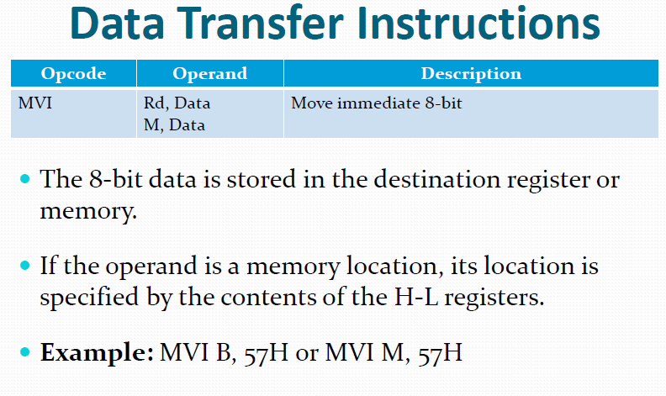

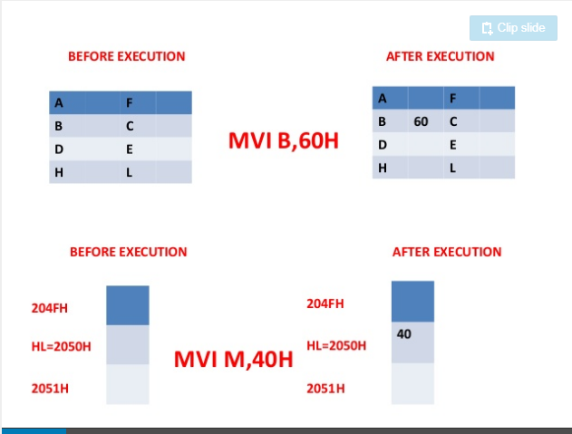

3



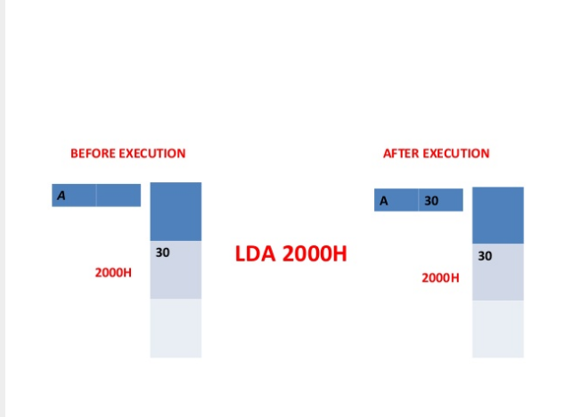

In 8085 Instruction set, **LDAX** is a mnemonic that stands for LoaD Accumulator from memory pointed by eXtended register pair denoted as “rp” in the instruction. This instruction uses register indirect addressing for specifying the data. It occupies only 1-Byte in the memory.



4

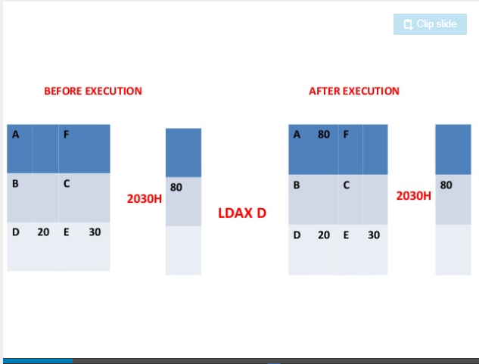

5





6

1



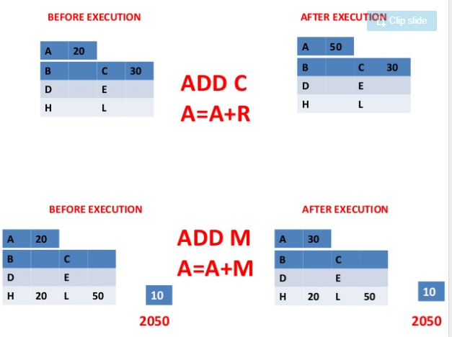



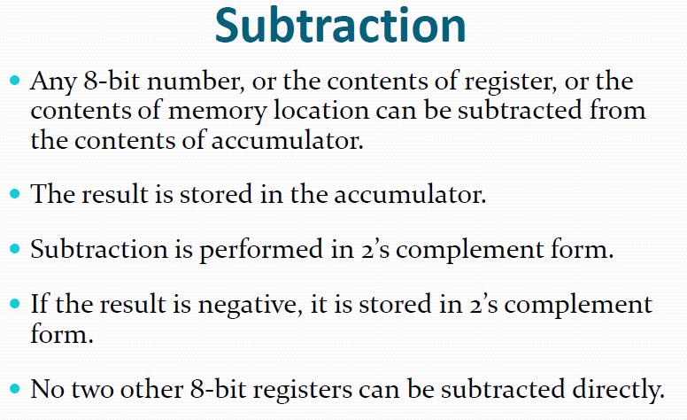





2

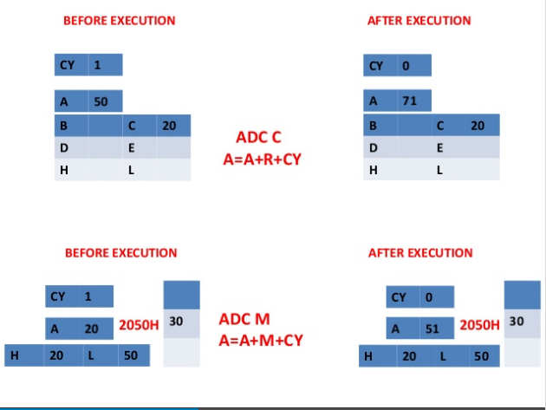

3



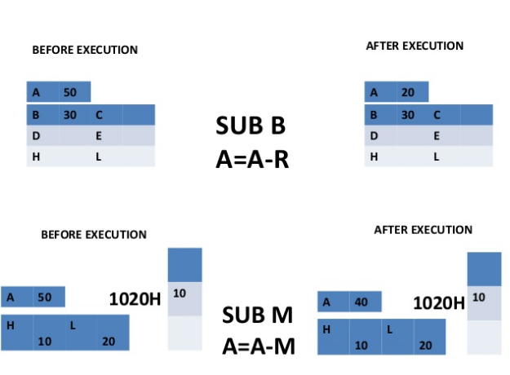

4



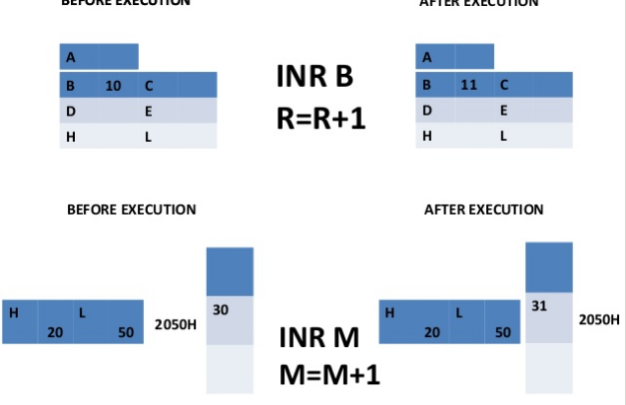



5





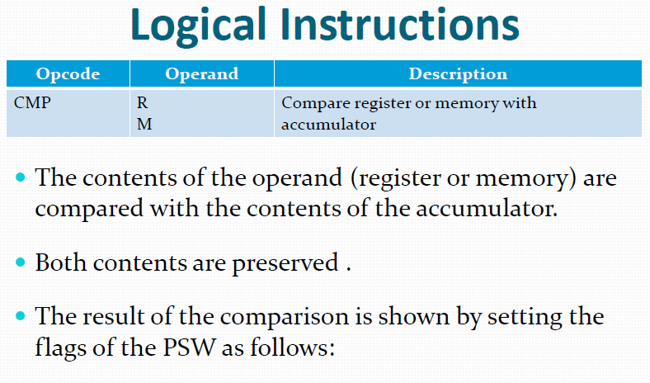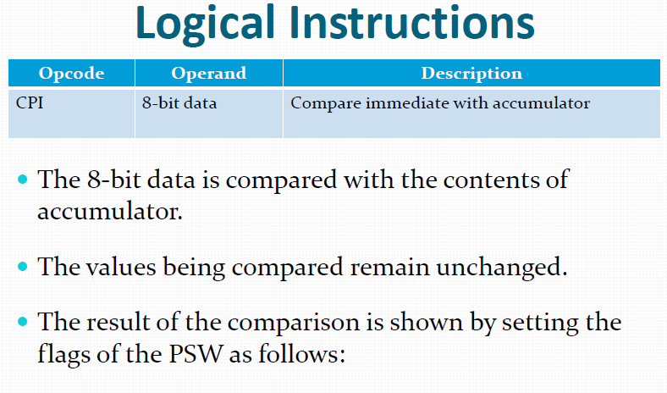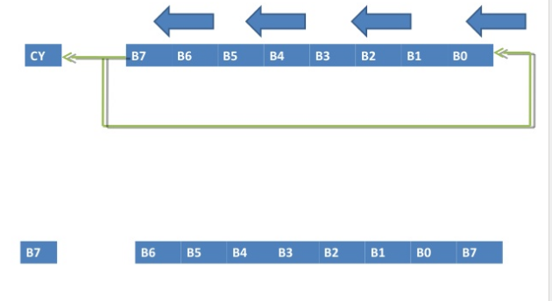

1

2

3

4

5

6





1

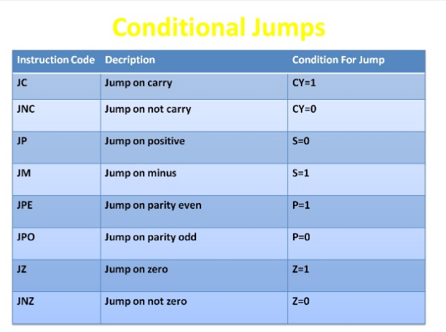



2





3



4



1

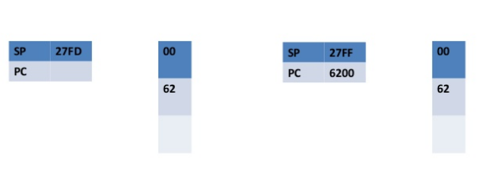



2

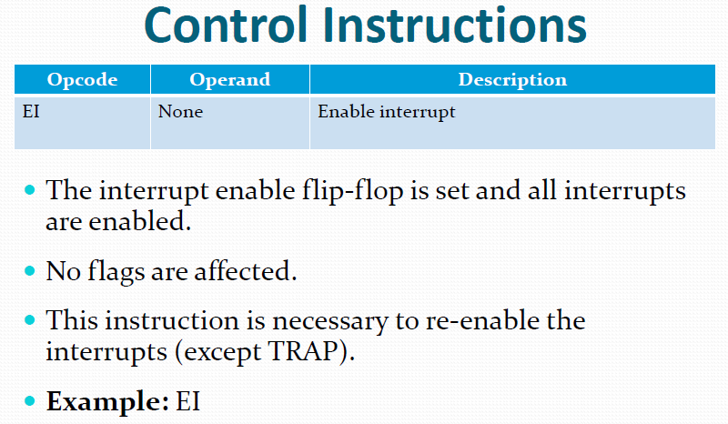

4

3